Getting the rotation from driving a circle

Get the latest bagfile name
Confirm the directory the bagfile is in (e.g. /home/ubuntu/.ros/bagfiles)
Get the latest bagfile name (e.g. 2021-09-26-17-40-23.bag)
Download the bagfile to the laptop

To start: $ rosrun plotjuggler plotjuggler

Select “Data” and select the bagfile
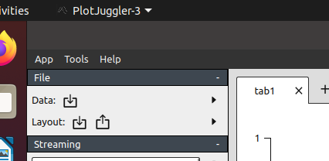

To plot odom x and y
Add a tab 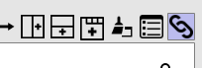
Open or add odom, x & y 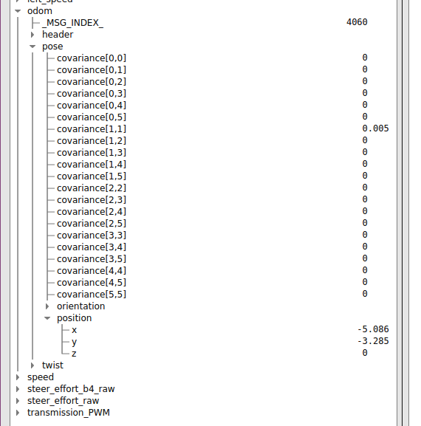
Select “x” then hold the left mouse button down and select “y” 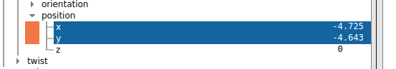
Using the right mouse button, drag the two on to the new tab; A “new X Y curve” window will appear.
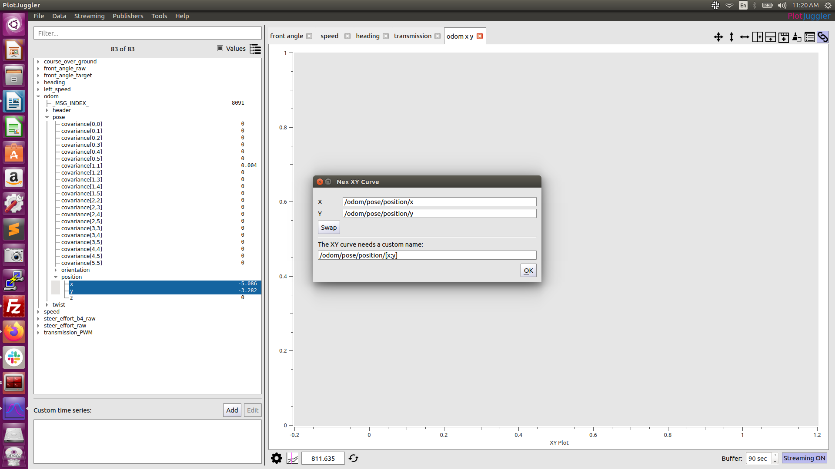

Click OK

Make tabs for the following
